

Zillow API Network

Implementation Guide

Zillow Business Development Team
July, 2006

Contents

Zillow Company Overview 3
Welcome to the Zillow API Network 3
API Implementation Examples 4
Find a Zestimate 4
Find a Zindex 6
Zillow API Technology Overview 7
Next Steps 7
Zillow and Partner Responsibilities 8
Zillow Responsibilities 8
Partner Responsibilities 8
Appendix A: Definitions 9
Appendix B: API Requirements 10

Zillow Company Overview

Zillow.com is an online real estate service dedicated to helping consumers get an edge in real estate by providing them with valuable tools and information.

Zillow offers valuations and data for more than 67 million homes in the U.S. Our Web site includes 3D maps of homes, historical sales charts and neighborhood market trend indexes. The information is free – Zillow's visitors do not have to give us any personal information and no one will call them.

Welcome to the Zillow API Network

Welcome to the Zillow API Network. As a Zillow Partner, you can now include Zestimate™ and Zindex™ home valuations data on your own Web site. This interactive content for over 67 million homes is free and easy to add.

What’s in it for you?

Enhanced user experience: Zillow home valuations are useful, fun and engaging to home buyers, sellers, and homeowners, as well as those just plain interested in real estate.

Opportunity for higher revenue: Visitors average 19 page views per session, resulting in increased time spent on your site. This translates into additional exposure for your real estate and mortgage advertisers.

Easy implementation: Development and implementation guides provide for simple integration of Zillow functionality on your domain.

A free service for your users: The home valuations are 100 percent free. No sign-ups. No subscriptions. No gimmicks.

Rich site content: Zillow offers a huge amount of information to your users, including tax and sale histories and comparable recent home sales. We have used this information to develop proprietary algorithms, resulting in valuations for over 67 million U.S. homes.

Take advantage of Zillow’s brand: Visitors recognize the Zillow.com brand; Zillow consistently averages two to three million unique visitors a month.

What’s in it for Zillow?

Affiliations to enhance the brand: By affiliating our site with well-branded partners, Zillow will increase the recognition of its brand.

Increased traffic: While most users will get what they want on the Partner site, a fraction will want to roll up their sleeves and dive into more data on the Zillow.com site.

Thank you for being a part of the Zillow API Network!

API Implementation Examples

The Zillow API Network will enable you to display detailed Zestimate™ home valuation, or Zindex™ median home valuation, data on your Web site in text and graph format. [See Appendix A for definitions of Zillow terms.] Zillow will provide the “menu,” and you can order as much or as little as you want. This flexibility enables you to customize content and format. The examples below show some possible formats, but the fields can be designed to reflect the visual themes of your Web site.

Find a Zestimate

To find a specific property, your site visitors can enter the address in a search box on your domain.
Address Input Search Fields

Sample search boxes

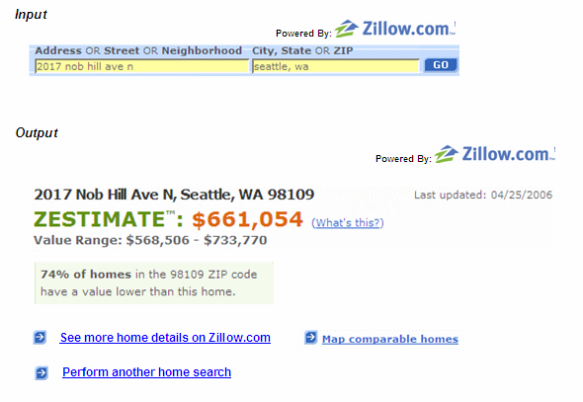
Provided By:

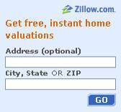

Note: These visual elements are not provided by Zillow. Partner sites create their own search boxes to solicit addresses from users.

Output Property Results
Sample property results

Provided By:

Note: You can choose which results to show. The output can include any or all of the following elements:
- Zestimate home valuation
- Zestimate value range (confidence interval)
- Chart of one-year historical Zestimates for the property, in either percent or dollar value change
- The full property address and geographic location (in latitude/longitude) – enabling you to plot address on third-party mapping engines (e.g., Google Maps, Yahoo Maps, etc.)
- The date the Zestimate was computed
- Zestimate ranking of the property within its ZIP code
- A set of identifiers that uniquely represents the property region: ZIP, city, county, state

Perform Another Search:

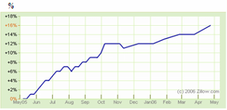

Output Comparable Property Results

Zillow can also return a list of addresses and Zestimates of comparable recently sold homes for a specific property. The results can contain the address, Zestimate, Zestimate value range, and weekly Zestimate change.
Sample results on comparable homes

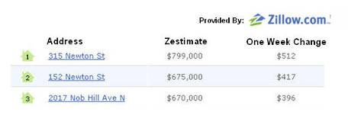

Find a Zindex

If your user chooses to search a region rather than a specific property, you can display the one-year historical Zindex (the median Zestimate for any combination of the following: ZIP code, city, county, state, country). This graph, which can be displayed in either dollars or percentages, can be included with Zestimate data from an individual home, or can be a standalone item.

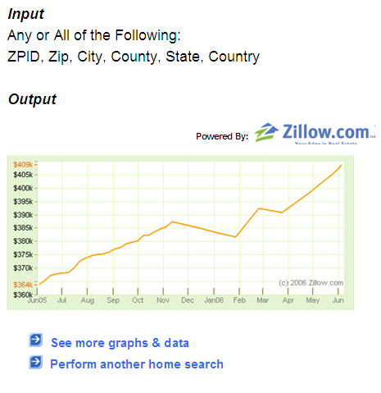
Provided By:

Zillow API Technology Overview

Third party-integrated Zillow content is made possible through the use of the Zillow Property API (Application Programming Interface). The Zillow Property API (ZP-API) is the interface that partner Web sites use to extract information from Zillow in real-time, without the need to reload a page [See Appendix A for a more detailed definition]. While it is very easy to integrate with a Web site from a developmental perspective, the API provides high level functionality and interactivity for users.

Your site visitors will see a search box or Zillow data element, like a Zestimate (itself the output of an API call) that, when clicked, will immediately “call” the Zillow database using the ZP-API and retrieve information to be displayed on your site. If your users are interested in even more information after the ZP-API call, they may choose to click on a link to Zillow.com. The link can spawn a new browser window so that users do not leave your domain.

We allow partners great flexibility in integrating Zillow content. You may display our data any way you want, on any page of your site, as long as it follows requirements outlined in Zillow and Partner Responsibilities, Appendix B and in our Terms & Conditions.

Next Steps

If you would like to join the Zillow API Network to integrate the ZP-API on your site, you will need to obtain a unique Zillow Web Services ID (or ZWS-ID). To do so, please contact BD@zillow.com [See Appendix A for more information].

Zillow and Partner Responsibilities

Zillow Responsibilities

As your partner in Web content integration, Zillow is committed to providing the following:
- Access to all available Zillow technology applications that perform callable actions using the ZP-API, for use on any page of your Web site
- Detailed data, as shown in this document, relevant to the ZP-API
- The ability for your users to conduct repeated calls using ZP-APIs on your site, thereby generating high numbers of page views per user
- A Zillow Web Services Identifier (ZWS-ID) that will be necessary for development and use of the ZP-API

Note: While Zillow will take all possible measures to ensure technical reliability and data integrity, we cannot guarantee ZP-API performance or data accuracy. For further information, please see the Terms and Conditions.

Partner Responsibilities

You become a Partner in the Zillow API Network at the moment you launch the content. In return, Zillow asks that Partners meet the following guidelines:
- Limit daily ZP-API calls to 1,000 to prevent fraudulent and inappropriate usage
- Include Zillow text, images, and links in all ZP-API input and output elements, as outlined in Appendix B
- Partners may not exact a fee from customers to use Zillow technology:
    - Partners may not directly charge customers to see only Zillow data
    - Zillow API Network functionality may be integrated into a “subscription-only” area of a Partner Web site where Zillow API tools are only available to paid users, as long as partner revenues are not tied to usage of Zillow API tools
- Partners may not require users to register or provide contact information when such information is primarily provided for the purpose of viewing Zillow data
- Partners may not distribute a Press Release to report integration of Zillow API functionality unless Press Release is approved by Zillow
- Adhere to all Zillow API Network Terms & Conditions

We hope that the inclusion of Zillow content on your site will provide value to your visitors, while enhancing your business, and we look forward to partnering with you.

Appendix A: Definitions

Partner: A Web site or company that elects to integrate Zillow API functionality into its site is considered a Partner immediately upon launching this technology. Partner status implies consent to the Zillow API Network Terms & Conditions.

Zestimate: A Zestimate™ home valuation is Zillow's estimated market value of a home. We compute this figure by taking zillions of data points and entering them in a proprietary formula. Zillow currently calculates Zestimates for 48 million homes and is constantly adding new Zestimates and improving the quality of existing Zestimates.

Zillow Property API (ZP-API): The API source code, Zillow textual information and Zillow visual output that partner Web sites use to extract and display real-time information from Zillow. The ZP-API may pertain to the current or historic value, and physical or descriptive attributes for a property or region (i.e., property, ZIP, city, county, state, country).

Zillow Property Identifier (ZP-ID): The ZP-ID is the unique ID for any given home. This is a data point used by Zillow to retrieve and display information about a property from our database. Zillow does not recommend that you display this to your users.

Zillow Web Services ID (ZWS-ID): The ZWS-ID is your unique developer identification code necessary to run ZP-API calls in the Zillow API Network. Contact Zillow at BD@zillow.com in order to obtain this identification number.

Zindex: The Zindex™ housing index is the median Zestimate for a given geography during a given time period. Therefore, as Zestimate values change, Zindex values tied to those Zestimates will also change.

Appendix B: API Requirements

Item / Element | API Requirements
Zillow Logo | Zillow input elements (i.e., search box) and output data (either user generated or automatic API call) must be accompanied by a Zillow logo. This logo must be visible any time Zillow functionality is visible. Use one or more of the logos available on the Zillow API Network page, unless granted permission by Zillow to use a different logo. Logos cannot be resized or edited in any way and must follow Logo Terms & Conditions.
Hot Links | The following output elements must be linked to Zillow.com:  - Zestimates/Zindex data returned from a ZP-API call *  - Property addresses returned from a ZP-API call *  - “Provided by Zillow” and Zillow logo  - “See more comparables homes on Zillow.com” text  - “See more graphs and data” text *  - “See more home details” text  - Disclaimer (see below)  All links should direct users to the URL supplied in the API, while Zillow logo should direct users to www.zillow.com.  * Note: The one exception to these required links is for API applications that automatically pull Zestimate / Zindex values without user address input. In such cases, the Zestimate value may link to additional partner-hosted Zillow content, which must then follow link requirements above.
Disclaimer | All Partner pages that contain Zillow data or tools must include the following text, typically at the bottom of the page:  Zillow.com, Zillow, Zestimate, and Zindex are registered trademarks or trademarks of Zillow, Inc. © Zillow, Inc. and suppliers. Any use of Zillow tools is subject to our general Terms of Use [link to http://www.zillow.com/corp/Terms.htm]. What’s a Zestimate? [link to http://www.zillow.com/howto/Zestimate.htm] What’s a Zindex? [link to http://www.zillow.com/howto/WhatsaZindex.htm].  Note: “What’s a Zestimate / Zindex?” text may be removed from disclaimer and included adjacent to Zestimate/Zindex values if desired. The text must still link to http://www.zillow.com/howto/Zestimate.htm or http://www.zillow.com/howto/WhatsaZindex.htm.

